User Manual

Edibl

Favour Yahaya favour.yahaya2@mail.dcu.ie 23369606
Hubert Iwanow hubert.iwanow2@mail.dcu.ie 23422334

Table of contents

- Logging in/out

- Navigating homepage/the swipe up

- Adding item with barcode/manual entry

- Removing item from pantry

- Viewing pantry/detail of food

- Recipe suggestions/details of recipe

- Saving recipe/viewing saved recipes

Logging in/signing up
In order to use any of the functionalities of the application you first need to log in or sign up. All account creation is done via apple authentication meaning all you need to do is click the continue with apple button. Upon first time use, you will then be taken to a screen which asks for verification. Once you authenticate the request , your account will be created. If an account has already been created you will immediately be taken to the homepage without any need for confirmation.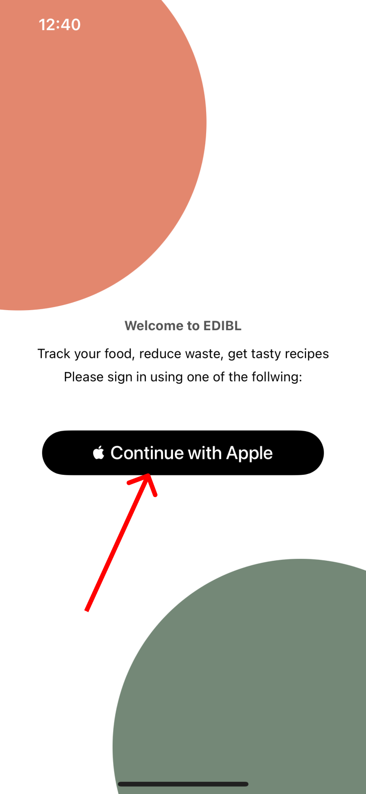

Logging Out
Once in the home page you are presented with a “Log out” button right underneath the welcome text. Clicking this button will lead to a “are you sure” alert. Upon pressing confirm you logged out of your account and taken back to the homepage. You cannot access any other page apart from the initial log in page prior to logging in.
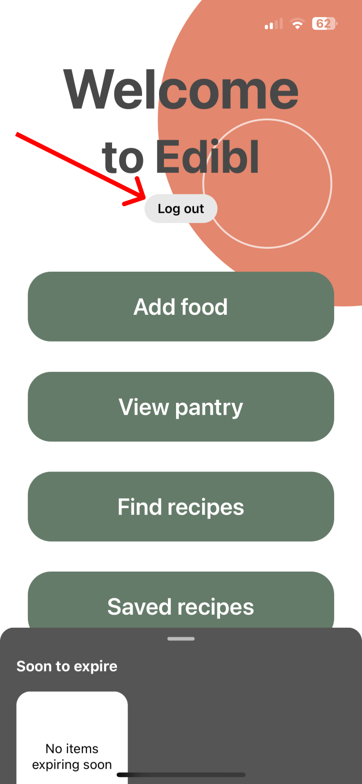

Navigating the homepage
Once you have logged in, you are greeted with the homepage of the app. There you will see four big pressable buttons, titled: “Add food”, “View pantry”, “Find recipes”, “Saved recipes”. Each of the following will redirect you to another page in the app, where you can access further information/features of the app. In the homepage there will also be a banner located at the bottom of your screen which can be enlarged by swiping up on it. Before swiping up you will be able to see all of the soon to expire items in your personal pantry. Upon further expanding the banner, you will be presented with information about recommended recipes along with your saved recipes collection. Each of the items displayed on the banner is clickable and can be used to access further information on a given item. The last button to be featured on the homepage is the “Log out” button, this as the name suggests will log you out of your account and bring you back to the login page. To enter back into the homepage from any other page simply swipe right from the left side of the device to access it again.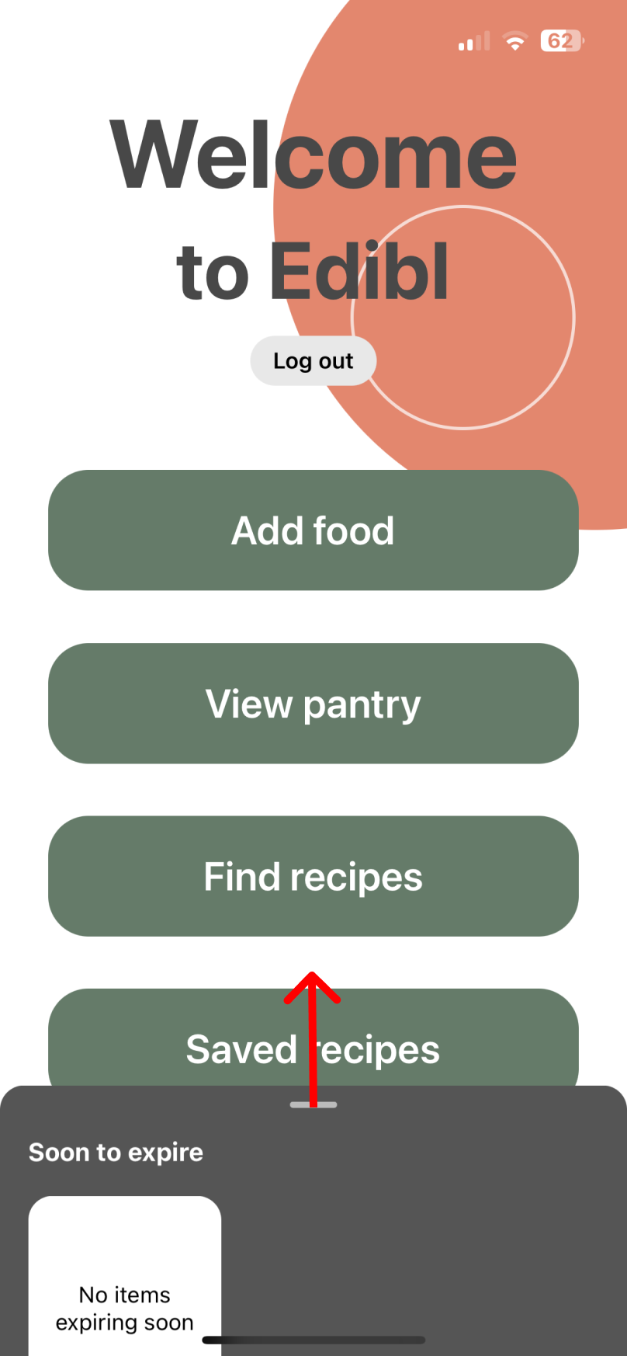

Adding item to pantry
After clicking the “Add food” button in the homepage you are taken to the barcode scanner screen. Upon the very first use of the barcode scanner you are presented with an alert which asks for camera permissions. You can then make the choice of whether you want to add foods manually or with the barcode scanner. The barcode scanner is the automatic choice, but if manual entry is preferred you can press the “manual entry” button below the barcode scanner box.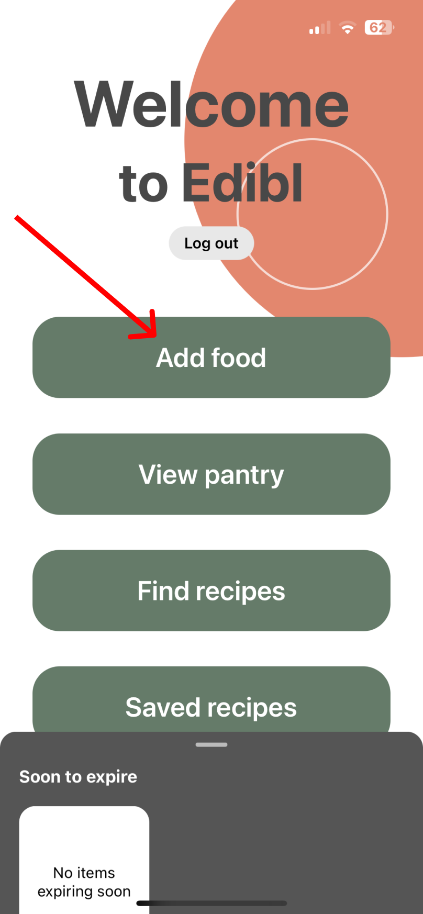

4.1 With barcode scanner
After accepting the permissions you are greeted with a camera view and a small box. The box is used as an outline for scanning the barcode of items. To scan a barcode, face the camera to the barcode and align it with the box. Once the camera focuses correctly on the barcode it can then be read by the scanner. The orientation of the barcode does not matter, the lighting also shouldn't be a problem as the phone detects low light situations and turns on the flash as needed. Once the barcode has been successfully read by the scanner you will be presented with a form which will require you to fill out certain information about the newly added item you have scanned. If the item is found within our food database, its information will be automatically inputted, all that's left to be input is the expiration date along with the storage location. The expiration date should be inputted using the Gregorian calendar, ie: day-month-year, along with hyphens. The storage location can be only one of three, being the pantry, fridge and freezer. If the item is not found in the database you will be prompted to complete the manual entry form for the item.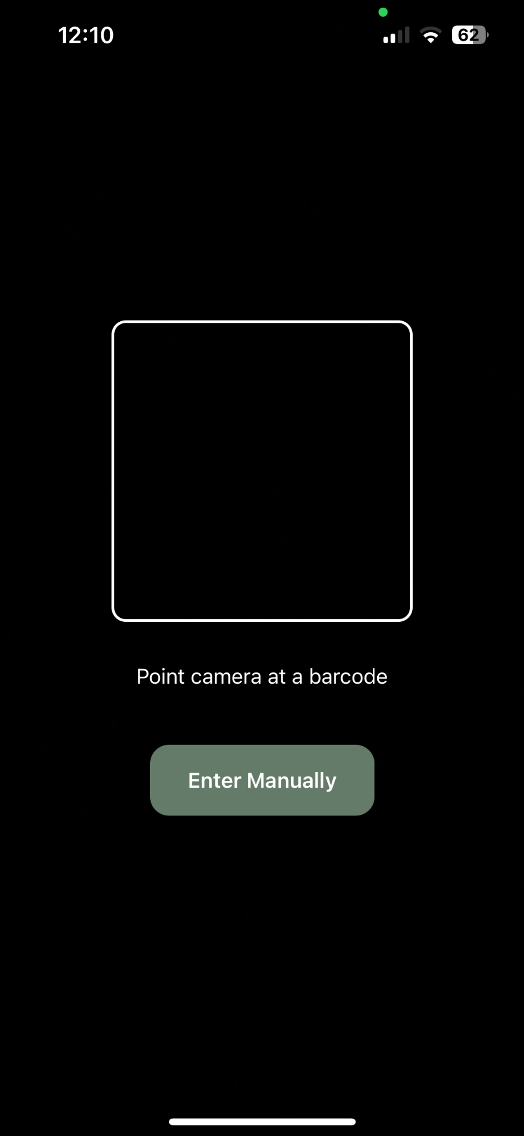

4.2 Manual entry
After pressing the “manual entry” button you will be presented with a form which will require you to enter various information about the item you wish to add. Firstly enter the name of the item. Secondly choose one of the listed categories which suits the item best. Thirdly fill out the expiration date found on the item using the Gregorian calendar and using hyphens. Fourthly, select the storage location of the item, choose between the pantry(normal room temperature), fridge and freezer.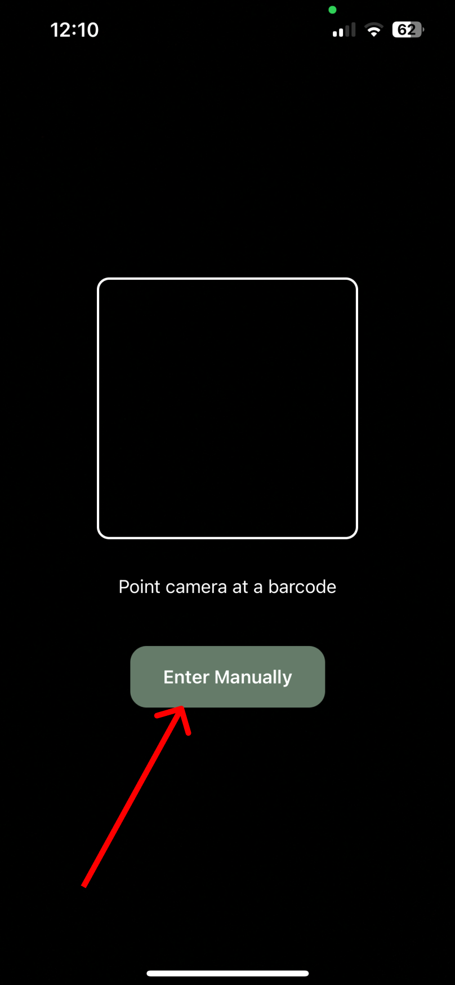

After filling out all of the required information(regardless of manual or barcode entry), press the “submit” button to add the item to your pantry. If all of the provided information is correctly entered your item will be saved. If any of the fields is entered incorrectly you will be unable to submit the item and will be prompted to resolve whichever issues arose within the form.

Removing item from pantry
Once the items in your pantry which are all used up or are no longer safe to eat, your next step is removing them from the pantry. In order to do so you navigate to the “my pantry page”. You then need to navigate to the stored location of the item. Beside the item there should be a trash can button. Upon pressing this button you will be shown a confirmation screen. Once you confirm the item is officially removed from your pantry.

When you make a recipe the item is also removed from the pantry meaning there is no need for manual removal. We will get into how to select and make recipes later on.

When an item reaches its expiration date, a notification will be sent reminding you to throw away the expired items. The expired items will be promptly removed from your pantry by the system.
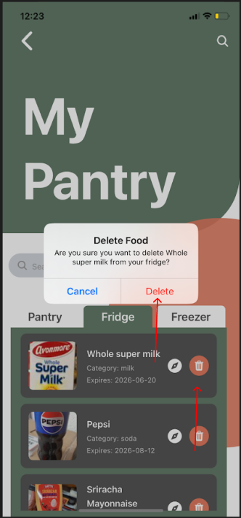

Viewing pantry/details of food
In order to view information about food you must again navigate to the my pantry page. You must then find the selected food you want to view. You then press the discovery button beside the remove food button. Open pressing this button, You are taken to a page where you can see all the information regarding that specific food item. At the very top you can see the shelf-life of the food (how many days are left). You are then given a button called change location which allows you to alter the location of the food item. You are then shown the safety window of the food based on its location and whether it's been opened or unopened. For example if you check for bread placed in the pantry it could show bread is safe to eat for 4 days after its expiry date if unopened and and 2 if opened. Below that you are then taken to a page which shows you how to tell if the food is still safe to eat. This section normally delves into any smells, discoloration texture changes e.t.c to watch out for.
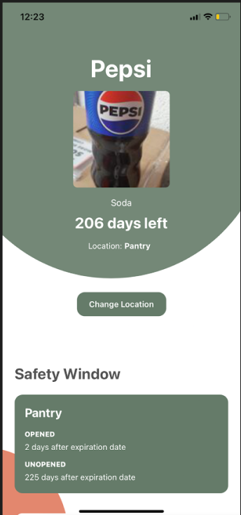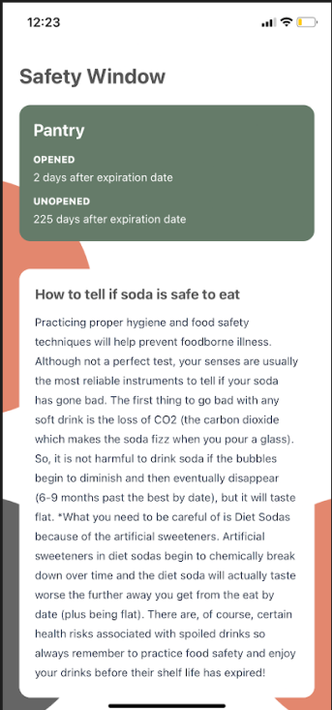
You can also view items from the homepage. You can click on an item in the “soon to expire section” which is located on the bottom of the page inside of the banner, and you will be taken to the same page.
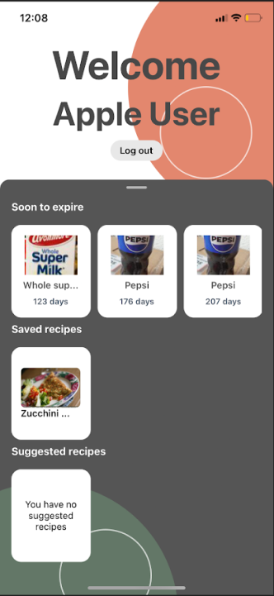

Recipe suggestions/details of recipe
Having food in your pantry means that you can now be suggested recipes to make. In order to view potential recipes you must click the “view recipes” button on the home page or swipe on the homepage bottom tab where you will see the suggested recipes section. The view recipes page has two sections: Viewing previously made recipes and finding recipe suggestions. These recipes are based on items existing in your pantry. The recipe recommendation system prioritises products which are soon to expire meaning it optimises the food in your pantry. The recommendation system also doesn’t recommend previously made recipes in order to offer a variety of choices to the user. If there are no new recipes available, the system will repeat previously recommended recipes based on the user rating. Once a specific recipe is clicked on/ selected, you are taken to a screen which displays all the information regarding the recipe such as, its preparation time, servings, ingredients needed and instructions. If you have made the recipe or are planning to make the recipe, you can click the make recipe button, which adds this recipe to your recipe history and removes all of the items from your pantry.

Saving recipe/viewing saved recipes
You are also able to save recipes as well. You can save recipes by going to the individual recipe page of an item and pressing the save button. To view all saved recipes, you must click on the button on the homepage or swipe up on the bottom tab in on the homepage.

